**Artificial Intelligence**

**Searching: Simulated Annealing**

**Name : Muhammad Husain Toding Bunga**

**Student ID : 1301153626**

**Class : IF39-INT**

**Lecturer SYM**

**Problem Descriptions**

In this case, we were given a mathematical function and we have to find the global minimum value of the function with x1 and x2 range from -10 to +10.

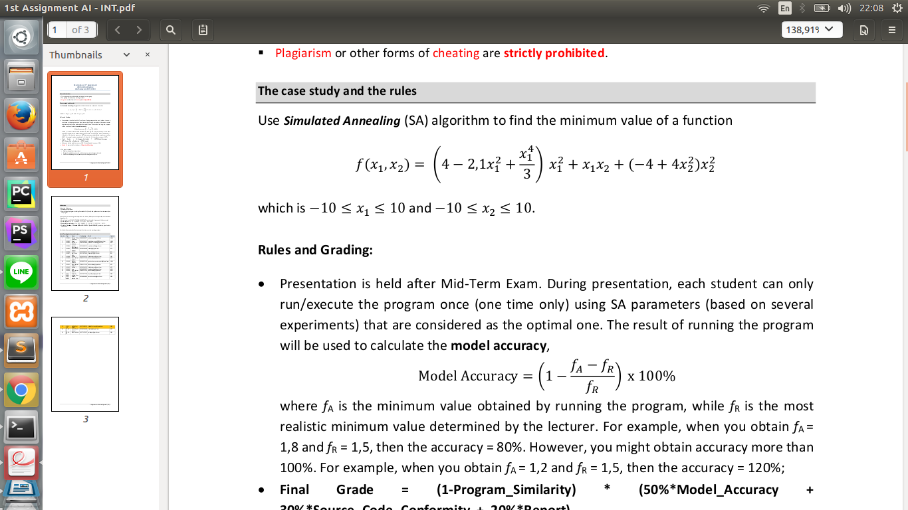  
Image 1: Finding a Global Minimum in this Mathematical Function

**My Design Method**

To solve this problem, I am using a searching algorithm called Simulated Annealing. By using Simulated Annealing, the program will try to find the global minimum by using the operators.

The algorithm itself will be implemented in a programming language named Python 3.

Here is my program’s design:

*Initial State* = Initial State is initialized by assigning a random value to x1 and x2 and use function fungsi(x,y) to count the result

*Temperature* = After several attempts trying to find the most optimal solution by changing the Temperature, I got **1000000** is the best value to have the most optimal solution.

*Operators* = Operators in my program is **random** from **-10 to +10**. Operators that already used will **not** be recorded.

*Annealing Schedule* = Schedule to change the temperature is set by this function below, but the function itself will only be used/called whenever the iteration **value(k) mod 3 is equal to zero**. This means the schedule will be **updated every 3 iterations**.

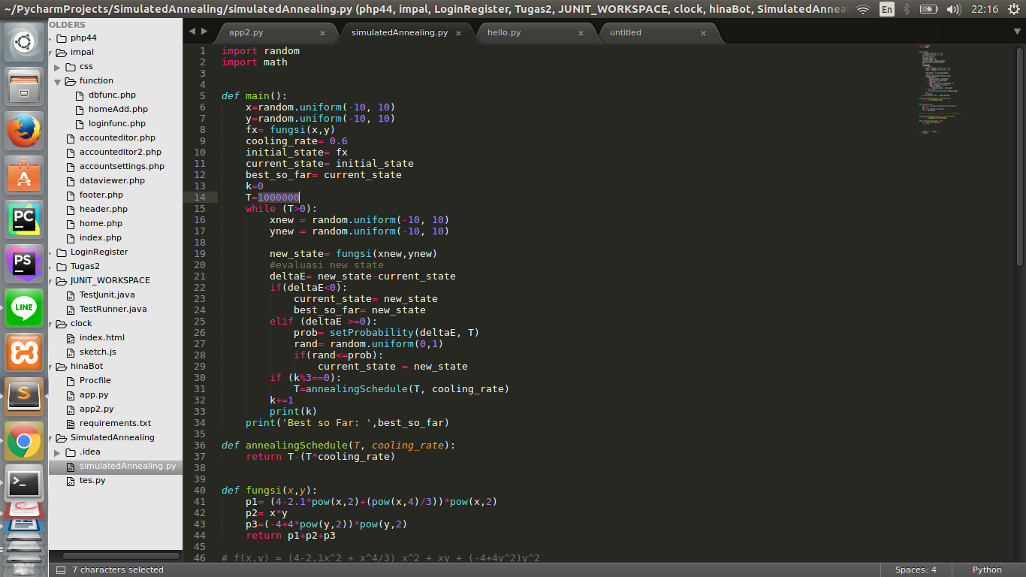

*Cooling rate* = Cooling rate is the percentage of Temperature that will be decreased in each iteration, I am setting the value of this variable to **60%** since I find that this value will result the most optimal solution.

*Looping condition* = The program will try to find the best solution as long as the value of the **temperature is larger than zero**.

**Searching Result**

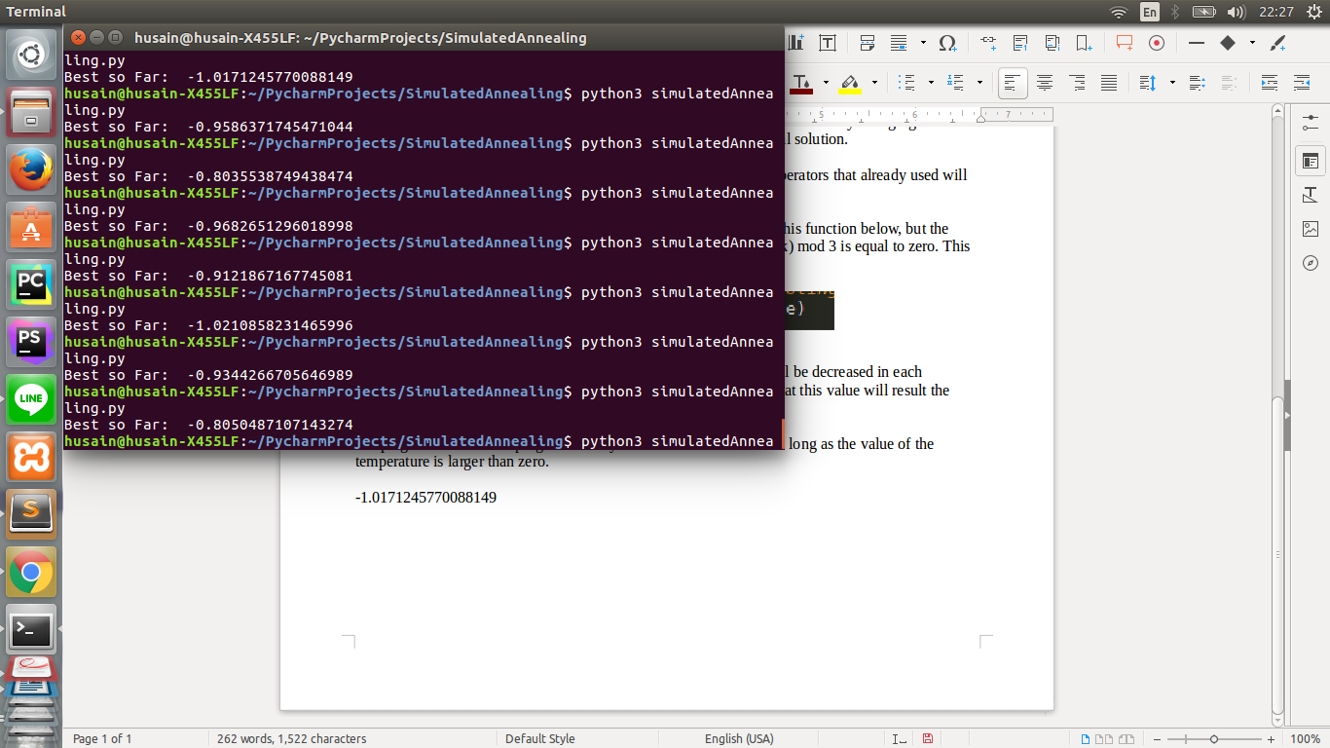  
Image 2: Screenshot displaying the program output after being executed/run.

After Several tries finding the best value. I find that -1.0171245770088149 is one of the best solution. Even though we might still can find a better result by rerunning the program again.

Unfortunately, not every run will result -1 . Sometimes it will result another value larger than -1. After several tries, I can assume that the range of the result will be around -0.84 **-** -1.017. Once again, this result is just an assumption after several tries, trying another run *might* result another value outside this range.